Logan Starr

November 15, 2016

SRA 468

The Laptop Theft

The process of finding the laptop thief or thieves is one that takes coordination between three different parts, Interview, Record, and Web. These three parts compile vast amounts of information that involves twenty eight different people. In order to narrow it down all three parts need to be looked at and compared. Each member of our group was given a part to look at.

For this group project I worked on the Web portion. In this part I analyzed four different areas of the web Facebook, Twitter, Angel, and Google Calendar. Looking at these four sections of the web gave me a good idea as to people’s movements and locations throughout the time of the thefts. Below is one example of information that was gathered from the Google Calendar:

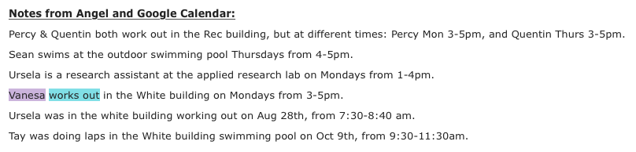The Google Calendar entry allows us to track people throughout the time of the thefts thus allowing us to eliminate people from the suspect list. Also useful were Facebook and Twitter posts that tell the time of when people worked, practiced, and worked out. Below are a few examples of Facebook and Twitter posts:

Facebook:

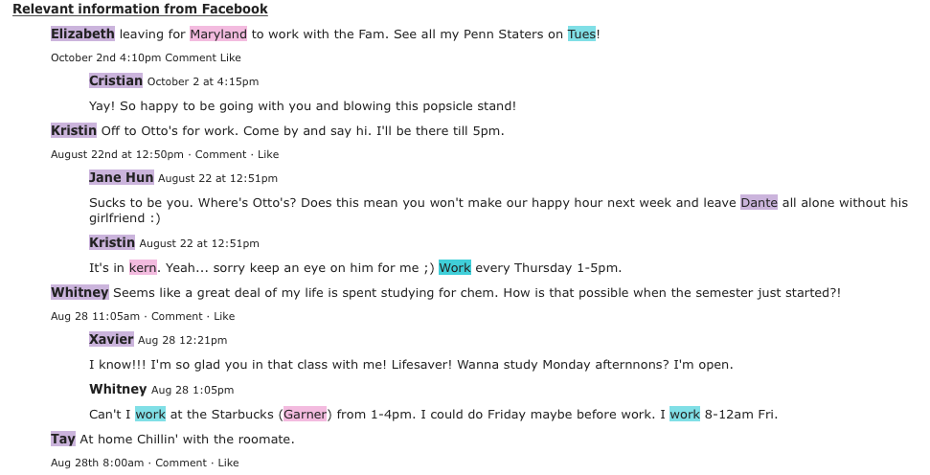

Twitter:

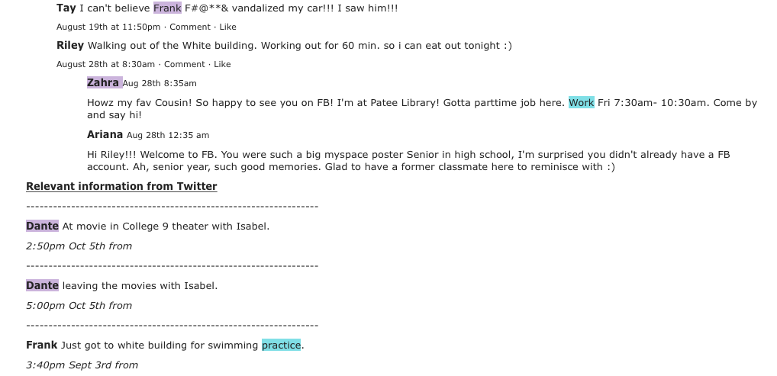

For the eight suspects I have narrowed it down to Vanessa, Whitney, Riley, Isabel, Xavier, Zahra, Frank, and Tay. I was able to narrow this down by using our network map and hypotheses from my other group members. The network map is displayed below:

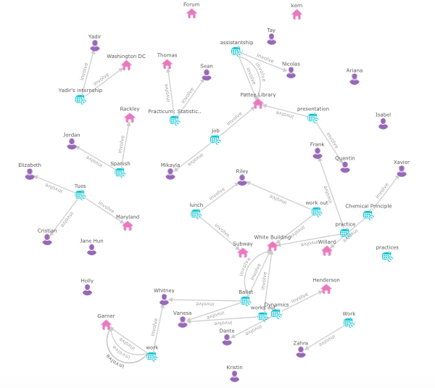

The hypotheses of my group members are displayed below:

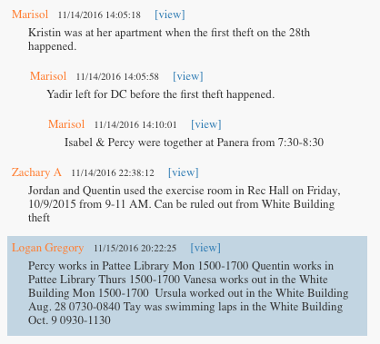

I was able to create my list of eight names by eliminating the other people in the list of persons of interest. The list of eliminated people is below:

Ariana:

Cristian: Went to Maryland during the first theft

Dante: Went to the movies during the third heist

Elizabeth: Went to Maryland during the first theft

Holly: Not enough information

Jordan: Was at another location during the time of several of the thefts

Kristin: Was working at Otto’s during some of the thefts

Luke: Not enough information

Mikayla: Not enough information

Nicolas: Was in New York during the third heist

Percy: Was working during some of the thefts

Quentin: Was at another location during the time of several of the thefts

Sean: Swimming in the outdoor pool during the second heist

Ursela: In the white building during the first heist.

Yadir: In D.C. for the semester

By using the information I was able to narrow down the people who could have stolen the laptops.

Narrowing down the list of suspects took time and team work. But by using the information compiled by my teammates we were able to make our lists of suspects. The system overall works well but there are several ways it can be improved especially in the scenario we were given. A focus more on the incidents instead of systems might be one way to improve the system. Overall it works well with collaboration and can improve group work